PRESS RELEASE
FOR IMMEDIATE RELEASE
______________________________________________________________________________

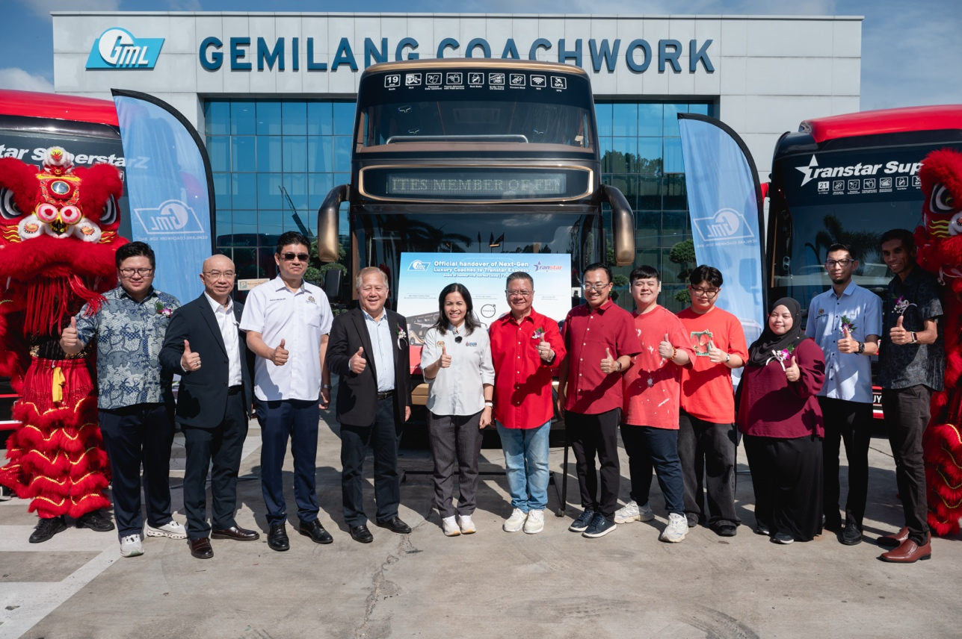
(From the left:
- Mr. Pang Jun Jie, Executive Director of Gemilang Coachwork Sdn. Bhd.
- Mr. Marcus Mak, General Manager of Volvo Buses Malaysia
- YB. Andrew Chen Kah Eng, ADUN Stulang
- Mr. Pang Chong Yong, Managing Director of Gemilang Coachwork Sdn. Bhd.
- YB. Teo Nie Ching, Deputy Minister of Communications & Multimedia
- Mr. Elson Yap, CEO of Transtar Group
- YB. Tuan Wong Bor Yang, ADUN Senai)

(From the right:
- Mr. Thiagarajan A/L Reganathan, Southern Regional Manager of Transtar Express
- En. Lutfi bin Ahmad, Timbalan Pengarah APAD Johor (agensi pengakutan awam darat)
- Cik Soleha binti Hj Mohd Yusof, Director of Transtar Express)

TRANSTAR EXPRESS LAUNCHES NEW GENERATION VOLVO B11R LUXURY COACHES WITH GEMILANG BODYWORK
Johor Bahru, 7th Feb 2026 — Transtar Express Sdn Bhd today officially unveiled and received its New Generation Luxury Coaches — the First Class Solitaire Suites and SuperstarZ, built on the Volvo B11R chassis with bodywork manufactured by Gemilang Coachwork Sdn Bhd. The handover ceremony took place at Gemilang Coachwork’s facility and was officiated by Yang Berhormat Puan Teo Nie Ching, Deputy Minister of Communications Malaysia.
The event marks a significant milestone in Malaysia’s express bus industry, reflecting a strategic collaboration between Transtar Express, Volvo Buses Malaysia, and Gemilang Coachwork to elevate standards in safety, comfort, technology, and sustainability in public transport.

Strengthening Industry Collaboration
In his remarks, Mr. Marcus Mak, General Manager of Volvo Buses Malaysia, emphasised that the handover symbolises a strong tripartite partnership founded on shared values of safety, reliability, and operational excellence.
“This handover represents more than the delivery of buses. It reflects our collective commitment to advancing premium long-distance travel with vehicles that deliver efficiency, dependability, and superior passenger experience,” he said.
He further acknowledged Transtar Express for its high service standards and reaffirmed Volvo’s commitment to supporting the operator’s growth and innovation.

A Landmark Achievement for Local Manufacturing
Mr. Pang Chong Yong, Managing Director of Gemilang Coachwork Sdn Bhd, described the occasion as a defining moment for both the company and Malaysia’s bus manufacturing industry.
He highlighted that the five newly delivered coaches are among the most advanced in the country, featuring first-class luxury seating, spacious interiors, and premium passenger amenities.
“These coaches are built on the proven Volvo B11R chassis and utilise lightweight aerospace-grade aluminium alloys in their construction. This enhances structural strength, improves safety, and increases fuel efficiency — delivering clear benefits to both the operator and the environment,” he stated.
Mr. Pang also commended the Gemilang team, suppliers, and partners for their dedication and technical expertise in delivering the project.

Elevating Premium Travel Experience
In her address, Cik Soleha Binti Mohd Yusup, Director of Transtar Express, expressed pride in introducing the First Class Solitaire Suites and SuperstarZ as part of the company’s continued evolution in luxury travel.
“This is a historic moment for Transtar as it marks our return to Volvo chassis after nearly 30 years, in partnership with Gemilang Coachwork,” she said.
She highlighted Transtar’s leadership in innovation, including being:
- The first express bus operator in Malaysia to provide onboard toilets across its entire fleet, and
- The operator of SuperstarZ, the first single high-deck coach in Malaysia and Singapore equipped with onboard toilet facilities.
Cik Soleha added that with the upcoming Visit Malaysia Year 2026, Transtar is well-positioned to support tourism by offering world-class premium travel experiences to domestic and international travellers.

Government Endorsement of Sustainable Mobility
Officiating the ceremony, YB Puan Teo Nie Ching congratulated both Gemilang Coachwork and Transtar Express for their contributions to the advancement of Malaysia’s public transport sector.
She commended Gemilang for its commitment to engineering innovation, quality manufacturing, green technology adoption, and development of skilled local talent — positioning the company as a global player in bus body manufacturing.
YB Teo also lauded Transtar Express for its pioneering role in introducing luxury coach services in Malaysia, setting new benchmarks in safety, comfort, and premium travel since the early 2000s.
She highlighted key strengths of the Volvo B11R platform, including:
- A high-performance, fuel-efficient engine,
- Advanced safety systems such as stability control and emergency braking assistance, and
- A robust, aerodynamically designed body structure for enhanced passenger comfort.
“This new generation of luxury coaches represents a progressive step towards a more modern, safe, and sustainable public transport ecosystem in Malaysia,” she remarked.
YB Puan Teo Nie Ching officially declared the Launch and Handover of the New Generation Volvo B11R Luxury Coaches open and wished all parties continued success.

